Patrick Austin

CS 491: Social Networks: Lab 6

21 April, 2018

This homework was completed with Gephi 0.9.2, using the provided nexusanon.net datafile.

1. Values were collected using the statistics tab of Gephi 0.9.2, with default parameters used for each centrality measure.

The node with the highest degree is Gary, at 37.

The node with the highest eigenvector centrality value is Paul, at 1.0.

The node with the highest pageRank centrality value is Paul, at .059638.

The node with the highest closeness is a tie between Abe, Andrea, Chris (node 62), Chris (node 151), Derek, Gary, Greg, Hung, Katie, Kevin, Mason, Orkut, Ricardo, Sanja, Sarah, Sonya, Stan, Thomas, Tom, and William, all with values of 1.0.

The node with the highest betweenness centrality is Eytan, at 561.926375.

2. I interpreted “energy layout” to mean a layout that minimizes energy, so I used the Force Atlas layout for this question. The most central nodes in each graph are colored red.

Eigenvector:

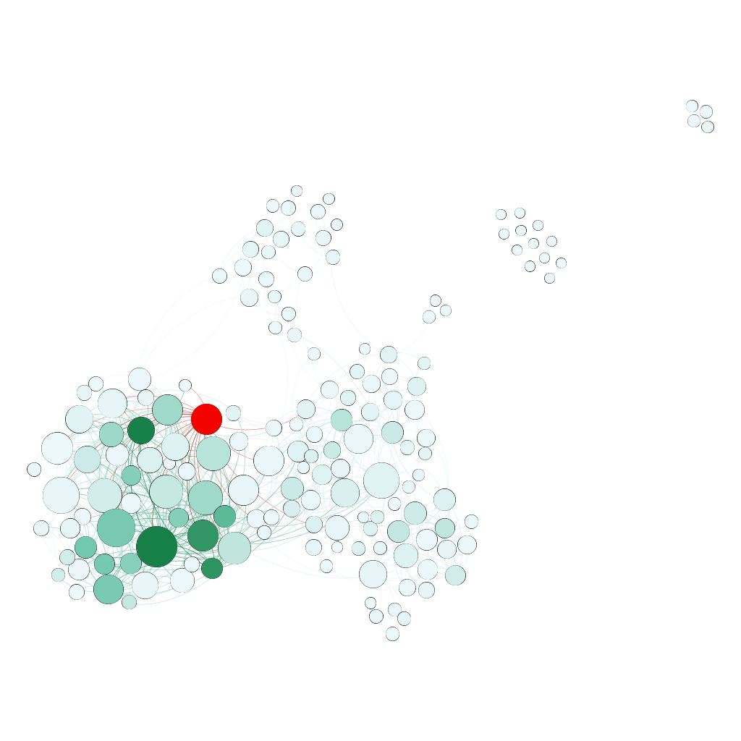

pageRank:

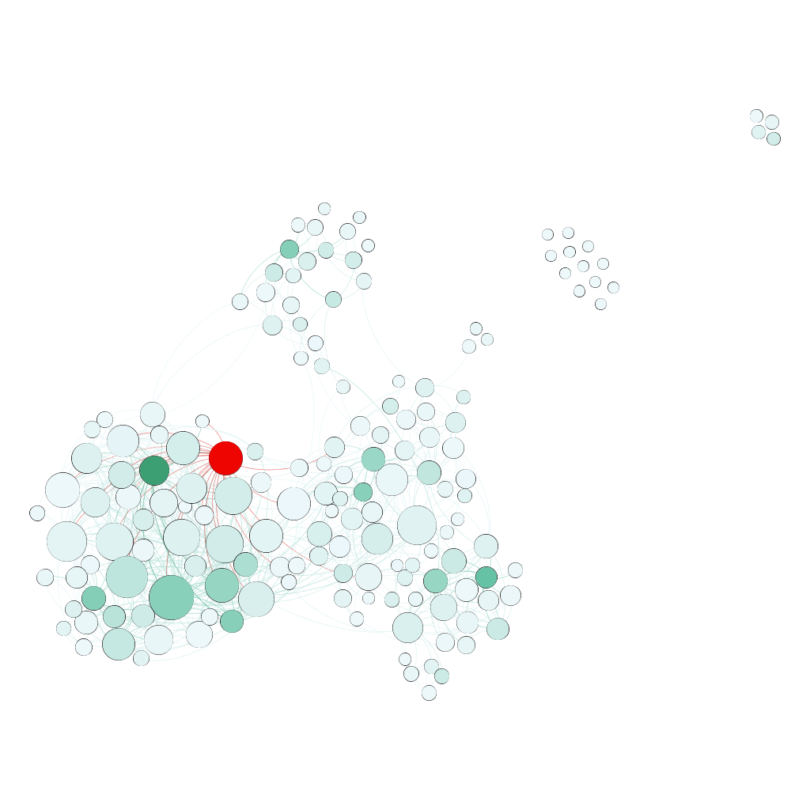

Closeness:

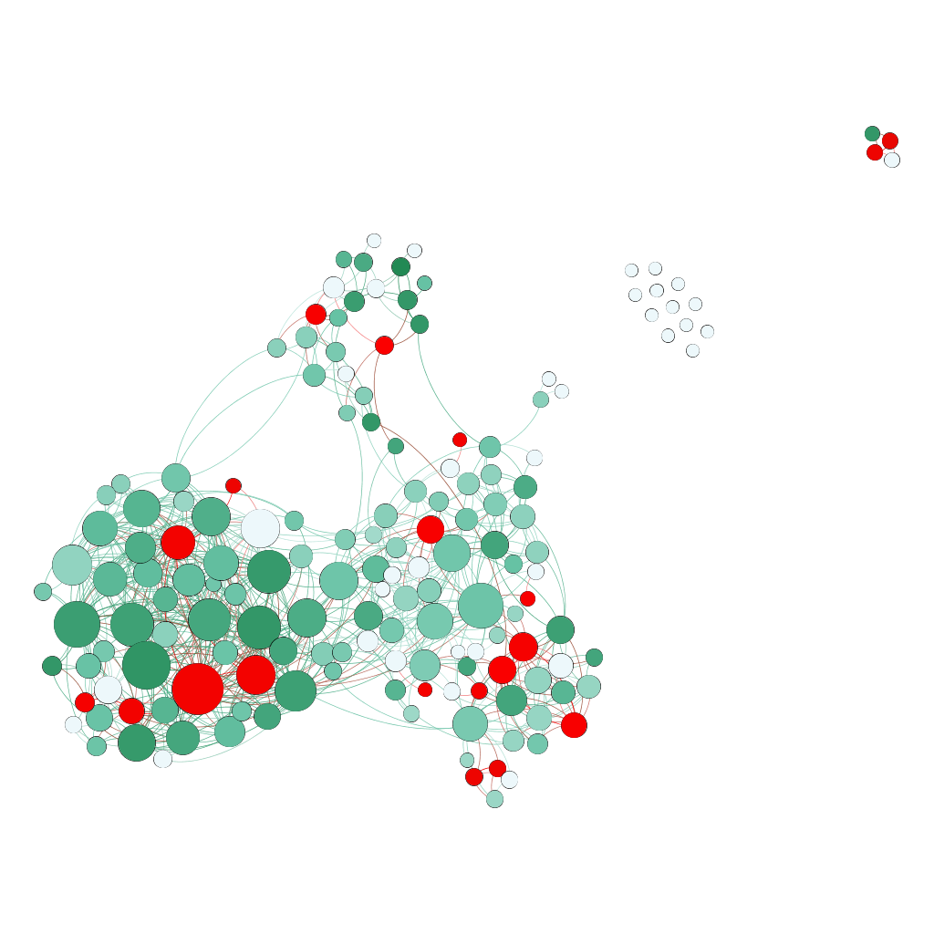

Betweenness:

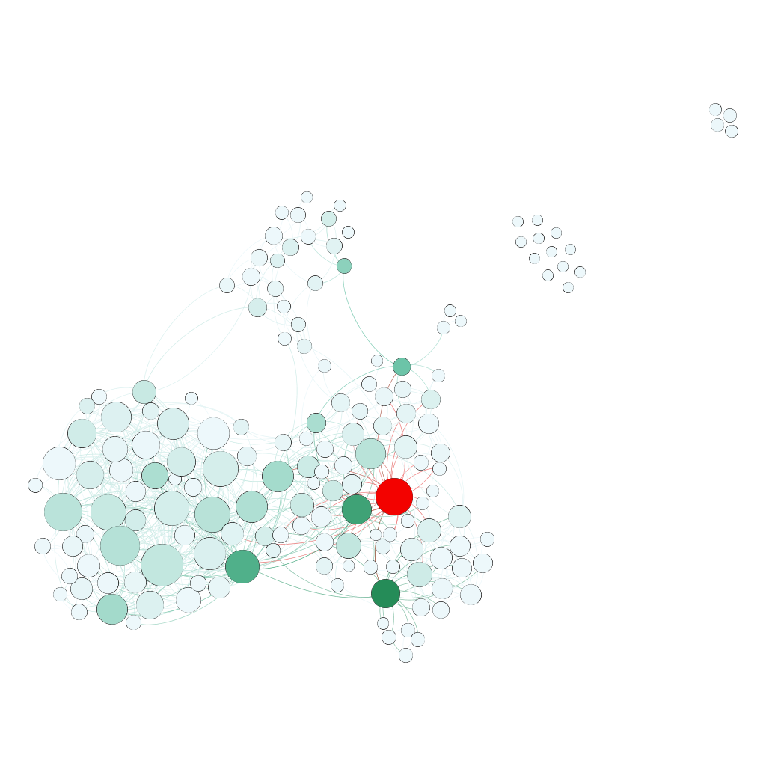

3.

Eigenvector:

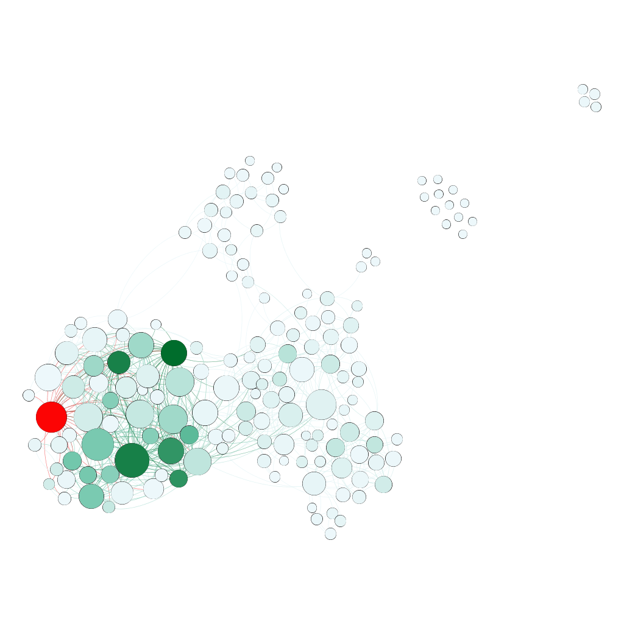

The highlighted node, Daniel, has the third highest degree, at 32, but has a quite low eigenvector centrality value of .015. This occurs because the node has high out-degree but low in-degree. Since Daniel follows many people but few people follow Daniel back, it makes sense his degree is high but his eigenvector centrality is low.

pageRank:

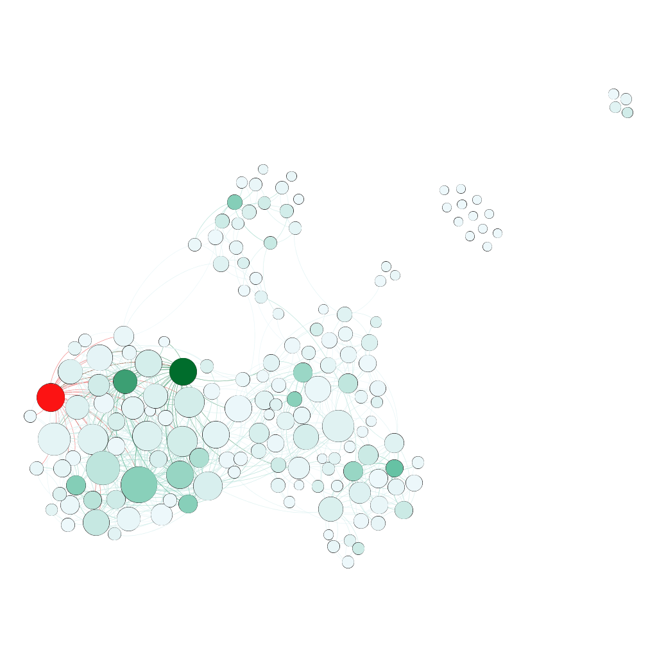

The highlighted node, Jiang, has the tenth highest degree, at 26, but achieves the lowest pageRank score in the graph at .00252 (tied with a number of other nodes). This occurs because Jiang has an out-degree of 26, and an in-degree of 0. Since no one follows him at all, the only amount of esteem PageRank gives him is the base amount given to every individual node as part of the algorithm; since no one follows him, he can’t acquire esteem from anyone else.

Closeness:

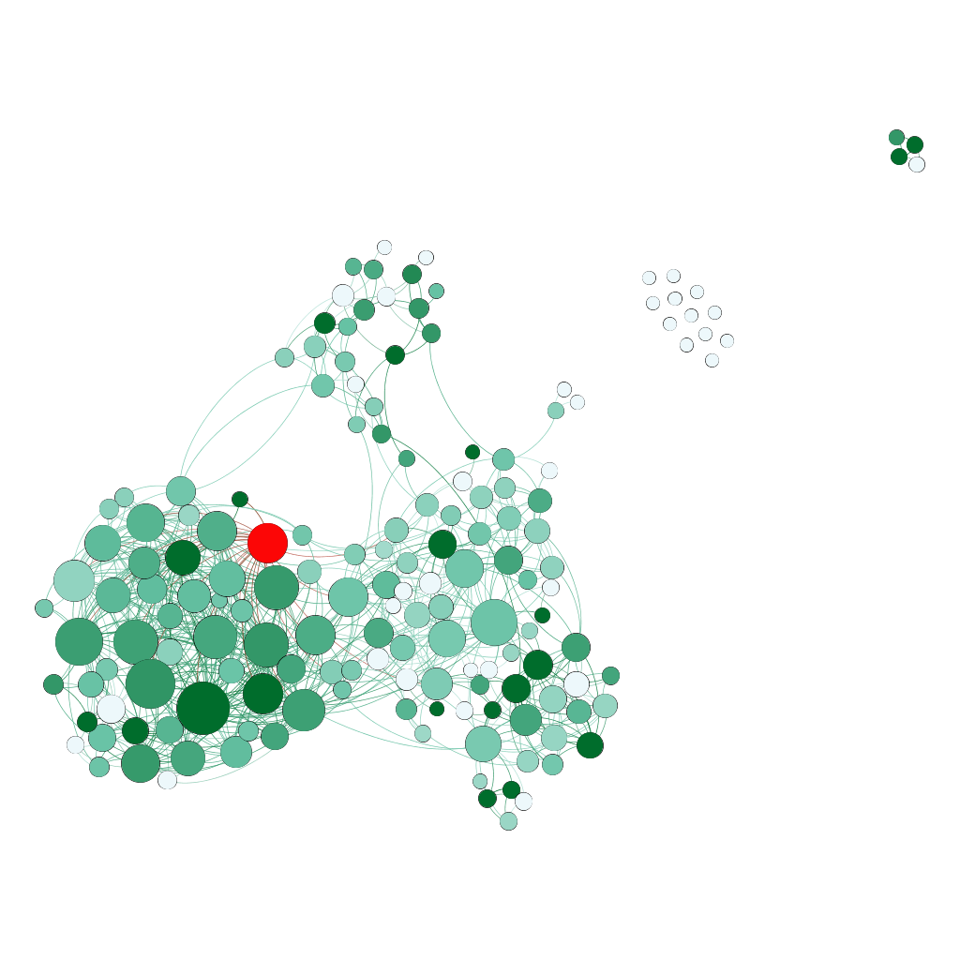

The highlighted node, Paul, has a high degree of 25 (and actually wins by eigenvector and pageRank metrics). Yet he has a closeness centrality of 0. This occurs because Paul’s out-degree is 0. Even though many people follow him, contributing to his high scores by other metrics, you can never leave the Paul zone and so he isn’t close to anyone.

Betweenness:

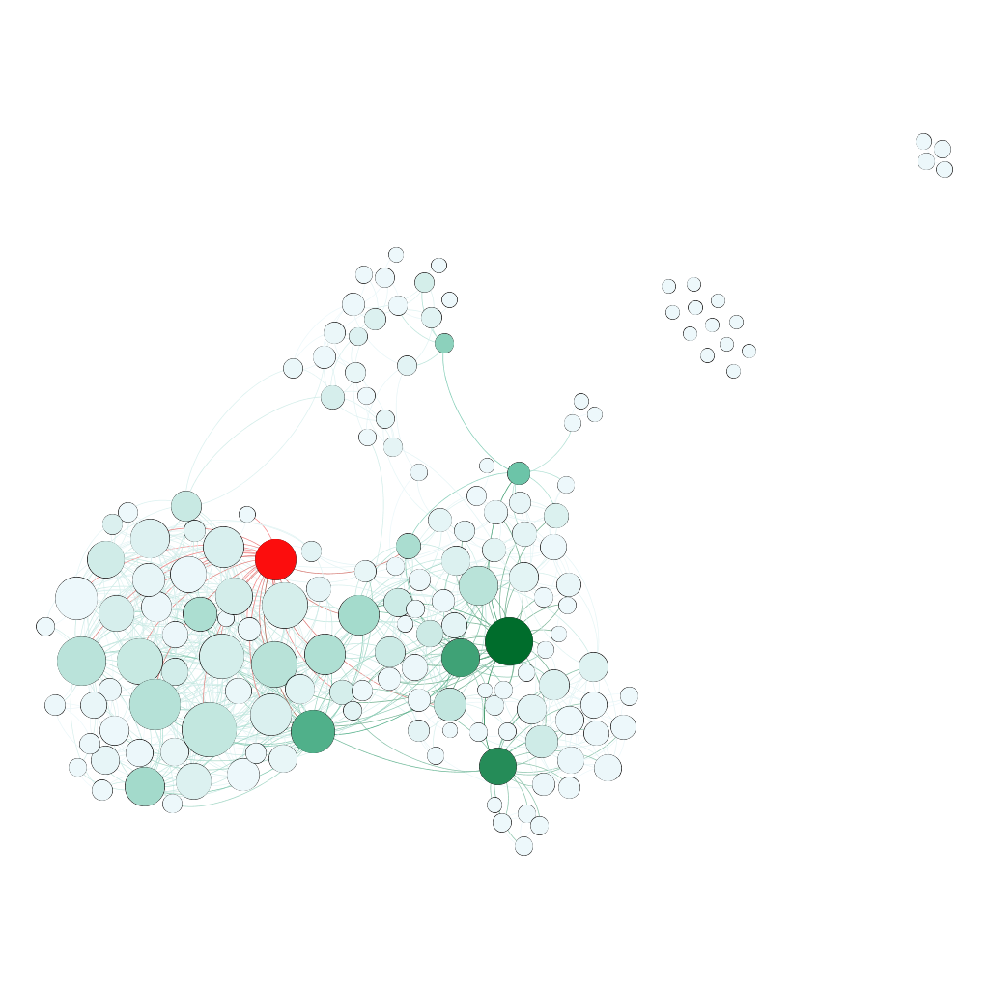

Likewise, Paul also has a betweenness of 0, despite his high degree value. Since he has no out-degree, no one can traverse to his node and leave again; therefore he is not between anyone and gets a betweenness score of 0.

4. The highlighted node, Heidi, has the sixth highest betweenness centrality at 201.333, but removing the Heidi node does not disconnect any vertices from the component. In the subsequent question I discuss notably changed nodes after Heidi’s removal.

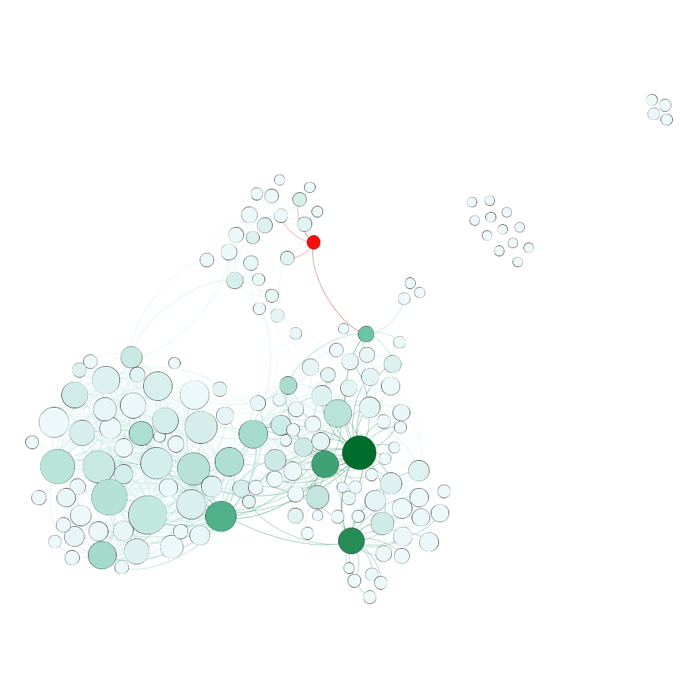

5. The highlighted node, Jure, experiences the largest difference in betweenness after the removal of Heidi. His score falls from 266.5833 to 37.25.

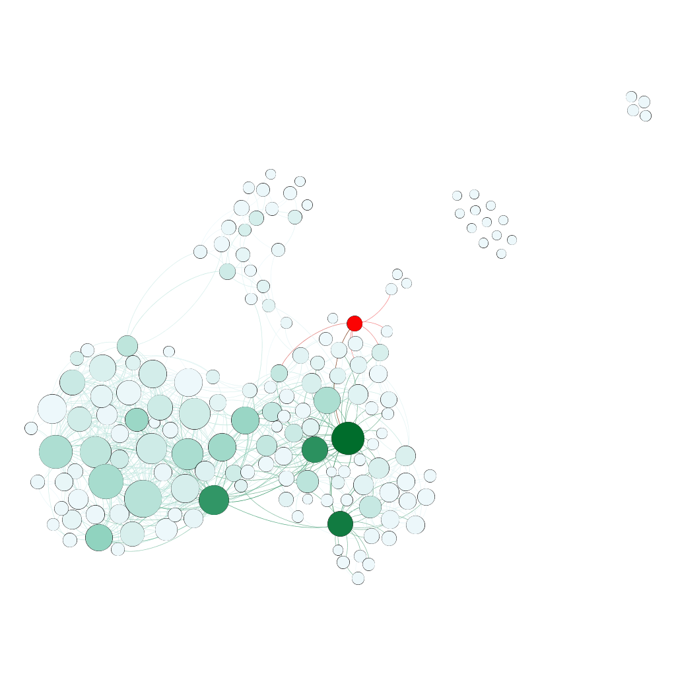

6. The highlighted node, Scott, experiences the largest difference in closeness after the removal of Heidi. His score increases from .435185 to .506329.

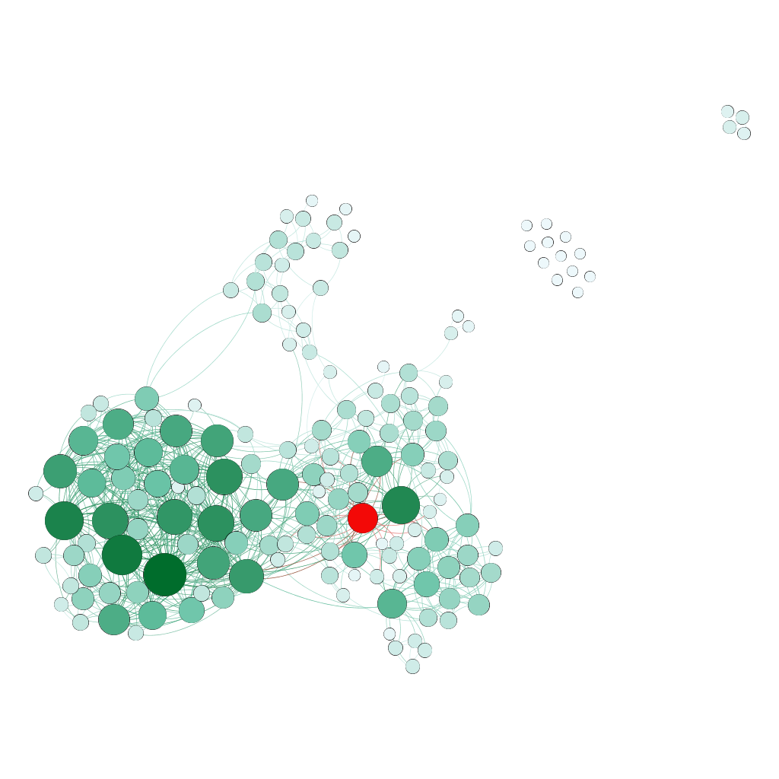

7. The highlighted node, E., experiences the largest difference in eigenvector centrality after the removal of Heidi. His (her?) score decreases from .01938 to .011598.

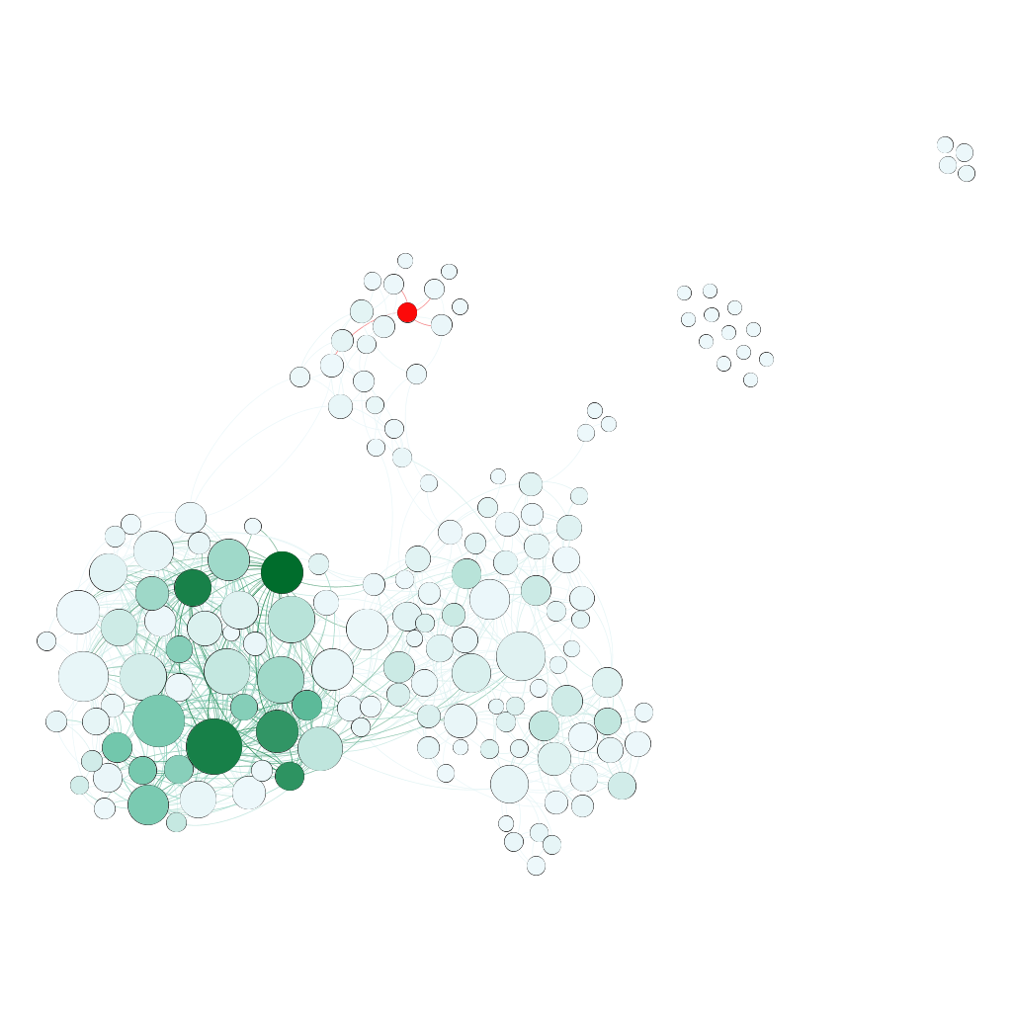

8. The highlighted node, E., also experiences the largest difference in pageRank centrality after the removal of Heidi. His/her score decreases from .008488 to .007059.

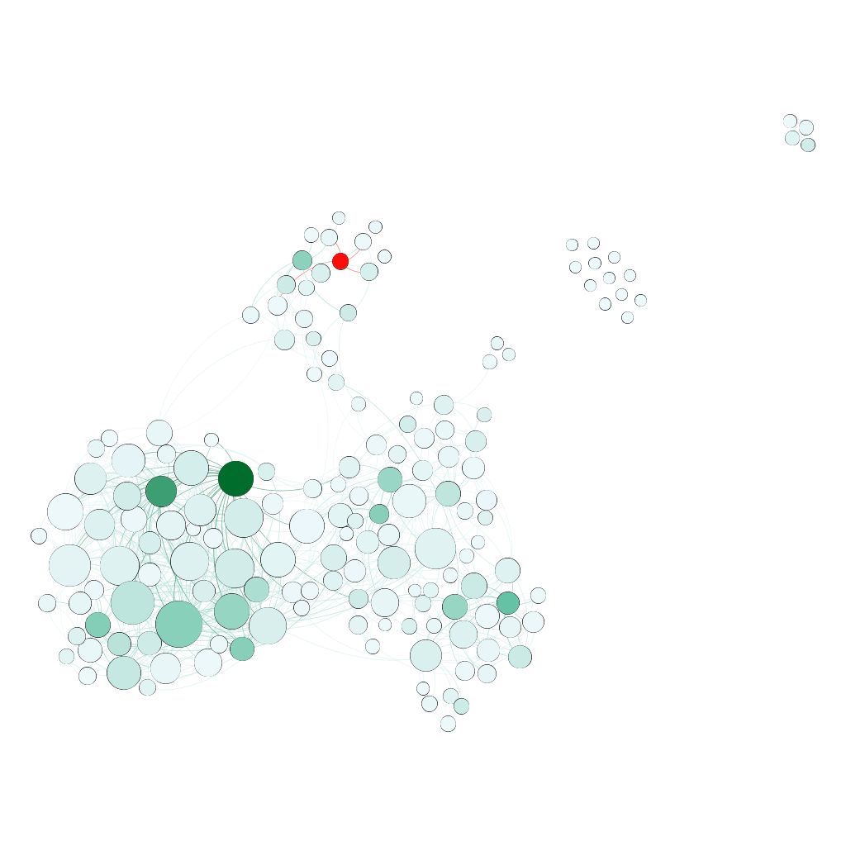

9. Jure experiences a large decrease in betweenness because he was the node directly connecting Heidi with the large connected component on the bottom of the graph. With the removal of paths going through Heidi, far fewer people go through Jure- now he’s on the periphery, without the important connection he had previously.

10. Scott experiences an increase in closeness because the removal of Heidi means that his average distance to all other nodes in the network increased. Basically, Scott’s higher closeness means that he, moreso than other nodes, depended on going through Heidi to reach everyone else efficiently. Her removal means that he has to take longer paths to reach everyone, so his closeness score increased.

11. E. experiences a decrease in eigenvector centrality because he/she (I’m going to say she) was directly connected to Heidi and depended on inheriting her centrality moreso than other nodes in the graph. Removing Heidi means E. doesn’t inherit any of her centrality, so her eigenvector score goes down significantly.

12. Similarly, E. experiences a decrease in pageRank because her centrality depended on inheritance from her link to Heidi. This link was comparatively more important to E.’s score moreso than any other change caused by Heidi’s removal.